Form 1396-2 EVP Minor ITS Form for Emergency Vehicle Preemption

This form may be used to document the ITS Architecture Conformity requirements for projects that include Emergency Vehicle Preemption (Light Emitting or Acoustic), but without other ITS components that would require further conformity documentation. It may also be adapted to similar types of projects. Refer to TEM Section 1301 for more guidance.

If any of the items listed below apply, you cannot use this form and should contact ODOT Office of Traffic Operations.
- Signal projects that require the integration of signal systems with FMS or RWIS.
- An ITS systems that involves multiple political jurisdictions.
- An ITS project that involves interagency systems.

Project sponsor should complete Sections 1, 2, 3, 5, 11 and 12 and review the remaining sections for relevance to the project and make any changes to this form that are needed.

This form Completed by:
Name:
Agency:
Title:
Phone:
Email:
Date:

Reviewed by:
Name:
Agency:
Title:
Phone:
Email:
Date:
---------------------------------------------------------------------------------------------------------------------
Reviewed by:
Name:
Agency:
Title:
Phone:
Email:
Date:
---------------------------------------------------------------------------------------------------------------------
Reviewed by:
Name:
Agency:
Title:
Phone:
Email:
Date:

Reviewed by:
Name:
Agency:
Title:
Phone:
Email:
Date:

Emergency Vehicle Preemption

- Scope of work
  - PID:
  - Location:
  - Project Description (from ELLIS or other sources):
  - Description of the Emergency Vehicle Preemption work:
  - Project Background (summary of Purpose and Need):

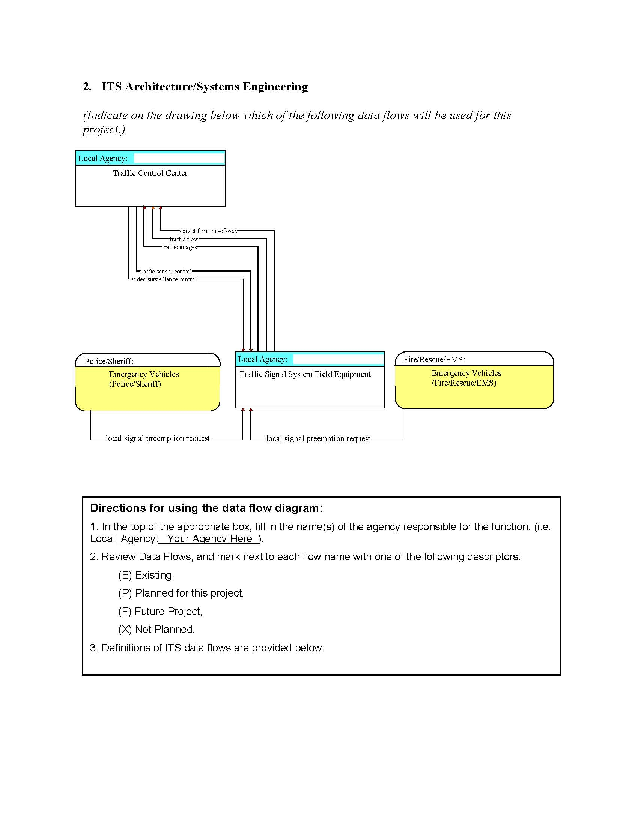

Data Flow Definitions:
Local Signal Preemption Request: Direct control signal or message to a signalized intersection that results in preemption of the current control plan and grants right-of-way to the requesting vehicle.
Request For Right-Of-Way: Forwarded request from signal prioritization, signal preemption, pedestrian call, multi-modal crossing activation, or other source for right-of-way.
Traffic Flow: Raw and/or processed traffic detector data which allows derivation of traffic flow variables (e.g., speed, volume, and density measures) and associated information (e.g., congestion, potential incidents).
Traffic Images: High fidelity, real-time traffic images suitable for surveillance monitoring by the operator or for use in machine vision applications. This flow includes the images and the operational status of the surveillance system.
Traffic Sensor Control: Information used to configure and control traffic sensor systems.
Video Surveillance Control: Information used to configure and control video surveillance systems.
List of Stakeholders
(Include a list of agencies and their roles and responsibilities. Also, provide a Concept of Operations that includes a statement of goals and objectives, a statement of the responsibilities and authority of the roles played in the process, and the specific operational processes. An example plan is shown below. It may be used, modified, or replaced as needed.)

AGENCIES:
Traffic: Provide for the safe and efficient operation of the city’s street system. They are responsible for traffic signal timing and adjustments and the maintenance of the signal system and other traffic control devices.

Police: Provide emergency response for safety and protection to the city. They need to arrive on the scene safely and quickly.

Fire/EMS: Provide emergency response to calls for fire, rescue, and medical aid. They need to arrive on scene safely and quickly.

Other:

CONCEPT OF OPERATIONS: An authorized emergency vehicle approaching a signalized intersection enroute to an emergency call has an activated emitter. The emitted signal is detected by an EVP detector mounted on the signal mast arm. The signal controller terminates any conflicting phases to bring up the through phase for the authorized emergency vehicle. Indicator lights mounted on the mast arms indicate that preemption is in operation.

The white/clear confirmation lights shall be mounted on the signal mast arms, one indication light facing each direction of approach. The EVP confirmatory light will remain dark (off) when the EVP Operation is not active. When the EVP is in operation, the indicator light shall flash or be steady under conditions defined below.

The approach that is preempted will receive a steady confirmation light along with the opposing approach. The controller will cycle through to bring up the circular green indications. The conflicting approaches will receive flashing confirmation lights and circular red indications.

The city will have the ability to download the database of preemption calls either from the controller or from the preemption equipment itself.

- Functional requirement of the project
(The following is a sample listing for one particular application. It may be used, modified or replaced as needed.)

- Vehicle based emitter is activated by emergency personnel in the vehicle
- Detectors mounted on the signal mast arms are responsive
- The traffic signal controller shall terminate any conflicting phases to bring up the through phase for the authorized emergency vehicle
- Indicator lights shall be mounted on signal mast arms (one for each direction)
- Indicator lights shall indicate that preemption is in operation
  - The indicator light shall be steady for the preempted approach and the opposing approach during preemption activation
  - The indicator light shall flash for the conflicting approaches during preemption activation
  - The indicator light shall remain dark when the preemption system is not active
- At the termination of the preemption phase, traffic signals shall return to the designated operation phase
- Preemption call history shall be available for downloading/printing via both the controller and the preemption unit for a set period of time

5. Analysis of alternative system configurations and technology options
(Provide a description of the various technologies considered and why the proposed technology was selected. The example below is for one particular application. It may be used, modified or replaced as needed.)

Both light emitting and acoustic emergency vehicle preemption systems were considered for this project. However, the design was selected because .

6. Describe the various procurement methods available and include rationale for the selected method

We will follow the State of Ohio rules and regulations for procurement of all materials and services. Due to the scope and scale of the project, low bid was the only applicable contract mechanism.

7. Identify ITS Standards that will be used in the project
(Indicate on the following list of standards for Signal Priority which standards will be implemented with this project. Typically, only NTCIP 1201 and NTCIP 1211 will be used for light emitting or acoustic designs. If other system designs will be used, the list in this table should be expanded or modified. For more information, visit http://www.standards.its.dot.gov/app_areas.asp?id=29.)

Standard | To be used on Project?
NTCIP 1201: Global Object Definitions | Yes
NTCIP 1211: Object Definitions for Signal Control and Prioritization (SCP) | Yes
APTA TCIP-S-001 3.0.0: Standard for Transit Communications Interface Profiles | No *
ASTM E2158-01: Standard Specification for Dedicated Short Range Communication (DSRC) Physical Layer using Microwave in the 902-928 MHz Band | No *
ASTM E2213-03: Standard Specification for Telecommunications and Information Exchange Between Roadside and Vehicle Systems - 5 GHz Band Dedicated Short Range Communications (DSRC) Medium Access Control (MAC) and Physical Layer (PHY) Specifications | No *
IEEE 1609.1-2006: Standard for Wireless Access in Vehicular Environments (WAVE) - Resource Manager | No *
IEEE 1609.2-2006: Standard for Wireless Access in Vehicular Environments (WAVE) - Security Services for Applications and Management Messages | No *
IEEE 1609.4-2006: Standard for Wireless Access in Vehicular Environments (WAVE) - Multi-Channel Operation | No *
IEEE P1609.3: Standard for Wireless Access in Vehicular Environments (WAVE) - Networking Services | No *
* Does not apply to light emitting or acoustic emergency vehicle preemption systems

8. Testing Procedures

All functional requirements are included in the specifications for the project and will be tested as indicated in the Traceability Matrix. Testing will be in conformance with the manufacturer’s specifications.

9. Traceability matrix

See traceability matrix attached to the end of this form.

10. Change control management

The City Engineer (or designated representative) will review shop drawings prior to installation. Any change orders will be handled per ODOT’s Change Order Policy.

11. Maintenance, operation and funding of the system after completion
(The maintenance plan addresses the repairs, upgrades, and plans for funding all aspects of the project. The Concept of Operations includes a clear statement of goals and objectives, a clear statement of the responsibilities and authority of the roles played in the process, and the specific operational processes and development and maintenance of the process. Example plans are shown below. If you prefer a different plan, insert it in place of the one below.)

MAINTENANCE PLAN: (agency) will own, operate, and maintain the preemption system after its installation. The Department will be responsible for operation and maintenance of all traffic signal and control equipment. The Department is also responsible for software upgrades and replacement of broken equipment. The Department has sufficient staffing, equipment, and tools for the required maintenance. Utility and maintenance costs for the preemption equipment are negligible and will be absorbed by the city. No additional staff will be required for maintenance of this equipment. Utility costs and maintenance of the traffic signal equipment are also the responsibility of .

12. Documentation for revising the Regional ITS architecture
(Submit the revised data flow diagram to the appropriate MPO. If no MPO exists for this area, contact the ODOT District.)

The revised data flow diagrams will be submitted to after completion of the project. The estimated contract completion date is .

EMERGENCY VEHICLE SIGNAL PREEMPTION TRACEABILITY MATRIX
FUNCTIONAL REQUIREMENT | SOURCE DOCUMENT | SOURCE DOCUMENT REFERENCE | TEST | PASS/FAIL | CORRECTIVE ACTION
1. Vehicle based emitter is activated by emergency personnel in the vehicle |  |  | Signal reception verified in controller and by detectors.
2. Detectors mounted on the signal mast arms are responsive |  |  | Signal reception verified in controller and by detectors. This is done for each approach of the intersection.
3. The traffic signal controller shall terminate any conflicting phases to bring up the through phase for the authorized emergency vehicle |  |  | Signal reception verified in controller and by detectors. This is done for each approach of the intersection. Visually verify that signal phasing has been preempted.
4. Indicator lights shall be mounted on signal mast arms (one for each direction) |  |  | Visual inspection
5. Indicator lights shall indicate that preemption is in operation  a. The indicator light shall be steady for the preempted approach and the opposing approach during preemption activation  b. The indicator light shall flash for the conflicting approaches during preemption activation  c. The indicator light shall remain dark when the preemption system is not active |  |  | Visually verify confirmation light operation in the field. This is done for each approach of the intersection. The lights should be wired through the controller to confirm true preemption; not through phase selector.
6. At the termination of the preemption phase, traffic signals shall return to the designated operation phase |  |  | Visually verify timing and phasing operation on site
7. Preemption call history shall be available for downloading/ printing via both the controller and the preemption unit for a set period of time |  |  | Verify that preempt calls are logged for data download. Check software for accuracy during the on-site testing

List the Functional Requirements from Section 4
.Source Document can be plans, specifications, special provisions, etc. where the requirement is found
Source Document Reference is the section, item number, page, etc. from this source document
How will this requirement be tested?
(To be completed after installation) Results of the test
(To be completed after installation) Corrective action taken

